President’s Quarterly 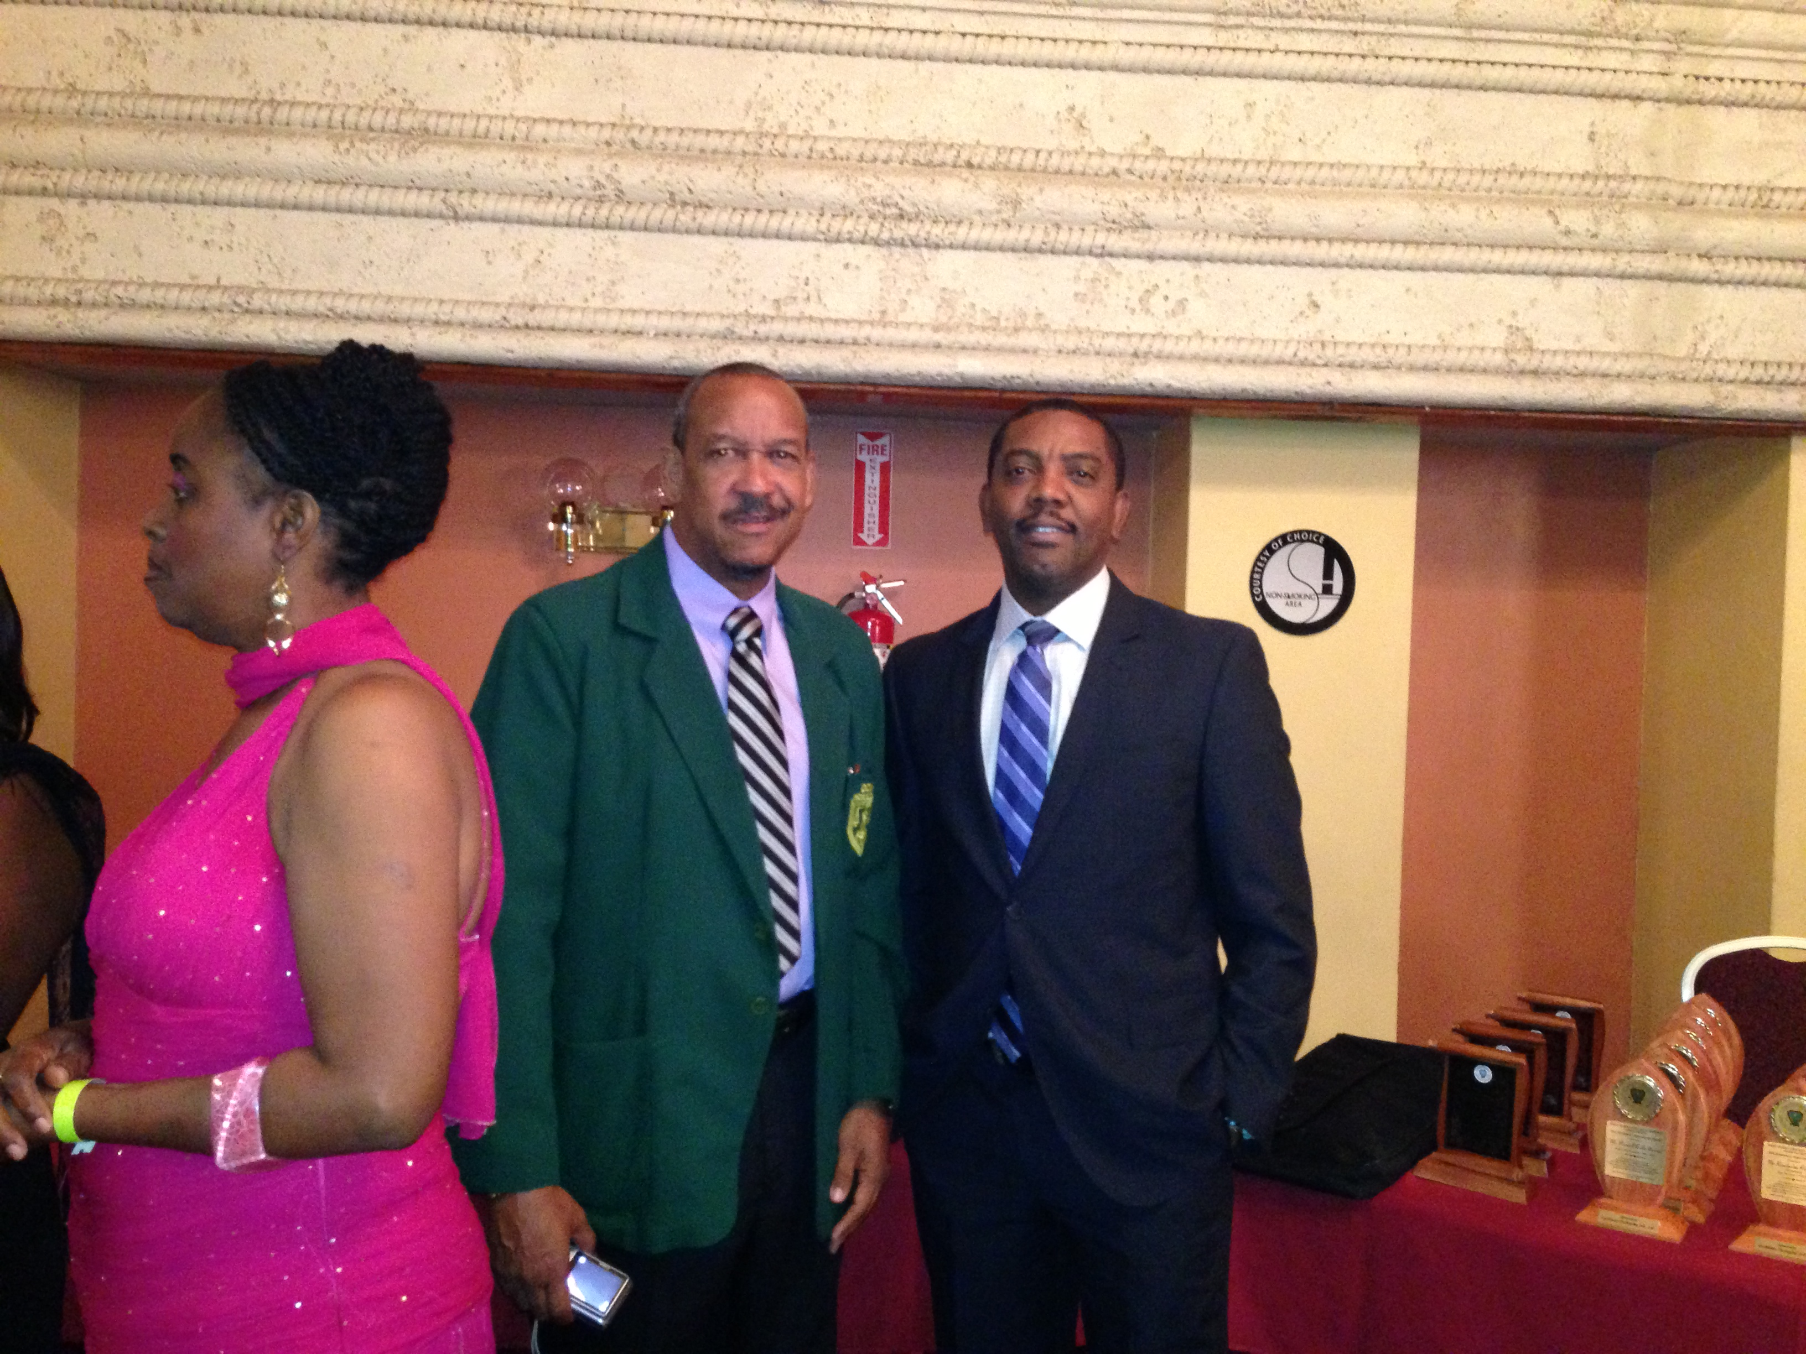
November 2015- January 2016
[Photo from left ..Lady, Billy Doctrove Ex. VP WICUA & Dave Cameron WICB President][T’T 2013]
Yet again another festive season has come and gone. It was a period when one should have been both merry and happy, nevertheless there are some persons who may have experienced difficulties financially and otherwise. On the other hand, there may have been others who had very little or no problems at all. Notwithstanding the varied circumstances ,the Quarterly wishes for all a prosperous and enterprising 2016.
Honorary life Member:
Messers Hartley Reid of Barbados, Anthony Lalacksingh and Harry Mahabal of Trinidad and Tobago were all rewarded for their Long and Faithful Service to WICUA. They were accorded the status of Honorary Life Members. They served in various capacities in their territorial Umpires Associations. Hartley Reid is a former President of WICUA, Anthony Lalacksingh a former Executive Vice President and Harry Mahabal a former Area 4 Vice President of WICUA. Their recognition and the conferring of the award took place at the WICUA Convention held recently in the United States of America in 2015.
Anthony Sanowar:
In the last Publication of the Quarterly umpire Anthony Sanowar was reported as having hailed from Guyana, it is to be noted that he is from Trinidad and Tobago.
Pension/Provident Fund:
The matter of the Provident fund which has generated much interest among some umpires is being attended to in earnest. Much work has taken place since the last publication. The WICB has indicated that they cannot at this time match any sum of money which may be lodged to the Fund by any umpire. Subsequent to this latest development a draft proposal was generated by the WICUA/WICB and sent to the senior panel umpires for their perusal and feedback. It is still work in progress.
Match Pass:
Territorial Associations are reminded to attend to the welfare of their constituents as it relates to match pass which would enable the umpires concerned to attend matches of all levels in their territory free of cost. Jamaica has benefitted and continues to benefit from such arrangements with the WICB. It is very important and indeed instructive that the umpires who would benefit should be proactive, so instead of waiting for their association to act they could in the process have dialogue with the powers that be in their area in such regard.
Cess:
Great strides have been made in the collection/payment of Cess to WICUA by the WICB panel umpires. All parties are working together in ensuring that what is to be done, is done in the interest of WICUA.
The Quarterly appreciates the role played by the senior panel umpires and the WICUA Officers involved in charting a successful course which is now being followed.
WICB/PCL:
The WICB conducted an umpires training seminar at the Accra Beach Hotel in Barbados November 2-4, 2015 just ahead of the Professional Cricket League [PCL} 2015 season. The following umpires were in attendance:-
Peter Nero
Joel Wilson
Gregory Brathwaite
Nigel Duguid
Leslie Reifer Jnr
Patrick Gustard
Verdayne Smith
Christopher Taylor
Lennox Abrahams
Danesh Ramdhanie
Zahid Bassarat
Nandkumar Shivsankar
Deightton Buttler
Carl Tuckett
Jonathan Blades
Christopher Wright
Jacqueline Williams [Female]
The seminar was conducted by Mr David Levens the ICC umpires coach.
Territorial Training:
Much dialogue with umpire Peter Nero the trainer designated, has been had and continues to be on the role he is expected to play. It is still work in progress.
As a precursor to the main event he has acceded to requests made that allowed him to make himself available, whilst carrying out his duties as umpire when on tour in the PCL competition, to conduct seminars. He has conducted two such seminars since, the first in Grenada on December 2 and the other in Jamaica on December 9, 2015. From all indications he was well received in both territories. He dealt with matters such as match management, personal preparation, conflict resolution and calculations among other things. The participants were attentive and benefitted from the exercise.
WICB Cricket Committee Meeting:
On the 14th November 2015 the WICB held its Cricket Committee Meeting at the Accra Hotel in Barbados. The meeting was chaired by Wicb Director Julian Charles. Among the members in attendance was the President of WICUA, the designated representative on the committee.
As per usual matters pertaining to West Indies Cricket, to include umpiring matters, were discussed. The matter of “illegal bowling” was discussed at length. It is of grave concern to all and sundry.
Whatever the planned action by those in authority or administration it cannot be overstated that the umpires do have a crucial role to play in an effort to bring back some semblance of sanity in such regard.
The WICB and the general public must have been saddened by the turn of events in recent times whereby several bowlers in the region have been pulled out of action because of their bowling action.
The Quarterly advocates that bowlers that are so involved and is to be identified at the earliest stage of practicing in the art of bowling and if they cannot be corrected at that stage they should be removed from the scene once and for all, then and only then will the situation be remedied.
Retirement of Peter Nero:
The WICB has four umpires that occupy the position of WICB ICC Panel, they are :-
- Peter Nero [Trinidad’Tobago]
- Joel Wilson [Trinidad’Tobago]
- Gregory Brathwaite [Barbados]
- Nigel Duguid {Guyana]
Peter, Joel and Gregory perform onfield duties, whilst Nigel does Television duties.
They have been performing their duties well.
Separate and apart from their umpiring duties they along with the other eight members of the senior panel have welded themselves into a formidable team, evident in the fact that their support for each other is unquestionable. Additionally their assistance to the umpires on the lower tier of the ladder has been tremendous.
After serious consideration Peter has decided to retire from the WICB ICC panel. He hinted recently that he is satisfied that his “baton” can be passed on to someone younger in age.
He should be commended for his unselfish attitude. He has served the sport well up to this point in time. Notwithstanding his intended resignation he remains a member of the senior panel. When his resignation is made official it is expected that Nigel Duguid will be reassigned and will in effect perform the role of onfield umpire. From all indications Umpire Leslie Reifer Jnr of Barbados will replace Peter on the panel and will be assigned Television duties.
The elevation of Leslie Reifer Jnr was by no means an automatic choice. The eight umpires listed from which he was selected had high level of performances over time. The field was narrowed down to two the other being Patrick Gustard of Jamaica. The selection process was democratic and fair.

Emerging Panel Umpires:
The WICB Professional League for the 2015-2016 Season commenced on November 14th. Umpires Deighton Butler of the Windward Islands, Carl Tucket of the Leeward Islands, Jonathan Blades of Barbados, Shawn Crawford of Guyana and Christopher Wright of Jamaica got their first opportunity to officiate in a match scheduled for four days at that level. Joining in the process was Jacqueline Williams of Jamaica the lone female. From all indications they performed well. It is instructive that they work hard and remain focused at all times.
For Jacqueline she has her eyes set on making it to the ICC panel of umpires who will officiate in the ICC Women’s World Cup tournament scheduled for the year 2017. As a precursor to such event she was appointed to and did officiate in the qualifiers in Thailand between November 28 and December 5, 2015. Her work was of such quality that it enables her to be selected in the panel that officiated in the final match. In order to assist her in her development the WICB has assigned Peter Nero to mentor her along the way. From reports she has been doing well. She has been bombarded by media personnel from many countries in the West Indies for interviews and such interviews resulted in several reports being carried both printed and electronically in relation to her rise and prominence in the field of umpiring from a gender perspective. There is much hope and optimism that she will make it to the ICC panel for the World Cup.
It is a fact that cricket umpiring has been dominated by males and notwithstanding that landscape has been interspersed by a few females, their participation to some extent has been minimal and miniscule. The position taken by ICC to empower women umpires is more than commendable. Now that the landscape is being adjusted it cannot be overstated that the cricket umpires association throughout the world needs to adapt to the change and in the process aggressively recruit suitable females to join their male counterpart in this regard.
It should be recognized that umpiring is not just for fun, among other things it guarantees an income which certainly is an important element towards economic success and financial happiness.
Caribbean Premier League: [CPL}
WICUA is now being involved in dialogue with the executives of the CPL as it relates to umpiring issues in the upcoming season. Decision on sensitive matters has had the input of the senior panel umpires. This type of approach can only do good thus ensuring that when the final positions are arrived at the ones to benefit would have been in the loop every step of the way.
WICUA Secretary Vivian Johnson who has been assigned the responsibility to lead the negotiations has the backing of the WICB in all respects. As part of his mandate he will seek to get the CPL administration to allow for the usage of the umpires performances under the caption of “Umpires Assessment” to be used by the WICB for internal purpose.
The Quarterly is optimistic that all parties will be satisfied at the end of the process.

WICUA Oral /Practical Examination:
The WICUA Oral’Practical Examinations were held on November 29, 2015 at several examination centres. Thanks to the WICB for providing the external examiners with airline tickets in order that they could effectively carry out their functions. Again the generosity of the WICB came to the fore which has been greatly appreciated.
Fundraising:
WICUA is really in need of money to assist in the running of the association. The Quarterly is unhappy that at this point in time no visible or tangible effort is made or communicated in that regard. It is time that the chairman of the committee articulate moves geared towards raising funds. Much talk about what would or could be done was placed on the table at the last WICUA Convention and the audience appeared upbeat and exited that a new day was on the horizon. It may be argued that it is early days yet, but from a distance it is appearing to be much talk and no walk. The committee needs to wake up, shake up and shape up. The year 2017 is just around the bend so action at this time is necessary. Dr.Seuss wrote as quoted; “You have brains in your head.
You have feet in your shoes.
You can steer yourself any direction you choose.
You’re on your own and you know what you know and you are the one who’ll decide where to go”
Exchange Program:
The Quarterly is reminding the territorial associations to engage each other in having the WICUA Umpires Exchange Program up and running soonest.
Umpire from the Americas:
Umpire Jermaine Lindo from the region of the Americas has replaced Umpire Mohammed Baksh on the WICB Umpires B Panel. The Quarterly welcomes him to the panel and congratulates him on being the person selected from the Americas. It is important that he understands that his elevation is a great boost for him and that he should not become complacent. It is a time when he will be required to work much harder, to keep his eyes fixed on a much bigger picture which is to reach the zenith of the ladder. Again the Quarterly reaches out and urges all Associations to recruit young and suitable persons to become umpires thus ensuring that the future be assured.
Edited Area Vice Presidents Report:
In order to effectively manage the affairs of WICUA the territorial associations were placed into Areas and those Areas are supervised by Area Vice Presidents.
Area 1 comprises Jamaica, Canada, Cayman Islands, Bermuda and the United States of America.
Area 2 The Leeward Islands.
Area 3 The Windward Islands
Area 4 Barbados, Guyana and Trinidad &Tobago
The Quarterly extends to all Area Vice Presidents the opportunity to supply information on a timely basis for publication of occurrences within their jurisdiction. So far there has been no response from Area 2. Area 4 has been spot on whilst Areas 1 and 3 have been inconsistent.
Barbados:
In Barbados five candidates were successful in their WICUA Final Written Examination and eight in the Oral & Practical Examinations
Umpire Somwaru of Guyana travelled to Barbados and umpire Patrick Grazzette of Barbados travelled to Jamaica where they both performed duties as External Examiners for the WICUA Oral & Practical Examinations.
Umpire Jonathan Blades officiated as standby umpire in the recently held West Indies versus Pakistan Women ODI series. He also made his onfield debut at Kensington Oval in Barbados in the current WICB Regional four day Competition. [PCL] Other umpires in action were Troy Tudor and Ryan Willoughby who performed standby umpires duties. Umpire Gregory Brathwaite officiated in the PCL and the Sagicor Super 50 Competitions. He will be officiating in the World U19 Tournament along with Nigel Duguid which is scheduled to be held in Bangladesh.
A cadre of men mostly under the age of thirty five years old is now being trained by the BCUA to
be umpires.

Jamaica:
At the recently held WICUA Convention held in the United States of America thirty umpires from Jamaica attended which represented the largest contingent in attendance. At the Convention Delegate Desmond Edwards collected a Citation on behalf of Former WICUA Secretary and Retired Test Umpire John R. Gayle which was presented by Mr. Eric Abrahams, President of the Borough of Brooklyn and New York.
Nine umpires were successful in the 2015 WICUA Final Written Examinations and Ten umpires in the Oral and Practical Examinations.
The Annual Retreat was held at the Holiday Inn Hotel, in Montego Bay November 15-18, 2015, one hundred and thirty seven members were in attendance. The Theme of the Retreat was “ Staying ahead of the game”. Much focus was on “Changes to the Laws ad Playing Conditions” “Pre and Post match meetings”“ Duties of the Standby Umpire” Match Management” and “ Preparation is King”
Neuro Surgeon Dr. Carl Bruce a Consultant at the University of the West Indies [UWI} spoke on the matter “ Concussions in Sport” and Dr. Peter Glegg spoke on “ Recovering from Errors and Staying ahead of the Game”
Jamaica in particular and the other cricketing countries in the West Indies continue to pay tribute to Jacqueline Williams for her achievements in the field of umpiring. At the Annual General Meeting of the JCUA held on Sunday January 24th she was presented with a large photograph of herself taken during a match.
There were several other matters that were addressed at the meeting chief among them was the Election of Officers for the next two years.
Elected were Umpires:-
- Norman Malcolm[President]
- Cecil Fletcher[1st VP]
- Hugh Fogo[2nd VP]
- Athol Hamilton[3rd VP]
- Daniel Warren Kidd[Secretary]
- Desmond Edwards[Asst. Secy]
- Christopher Wright[Recording Secy.]
- Terrence Richards[Treasurer]
- Everton McIntosh[Asst. Treas.]
- Maurice Chung[Member]
- Omar Neil[Member]
- Verdayne Smith[Member]
- Earl Pottinger[Member]
- Everton Davis[Member]

Dr. Peter Glegg was accorded the status of Honarary member of the JCUA.
Cayman Islands:
The Cayman Islands held its Annual General Meeting on the 26th January 2015 and the following Members were elected :-
- Livingston Baily [Pesident]
- Leon Watson [ VicePresident]
- Carey Williams [Secretary]
- Odette Campbell [Treasurer]
- Zitroy Robertson [Member]

Canada:
One umpire was successful in the WICUA Final Written Examination and four in the Oral and Practical Examination. There has not been any cricketing activity in the region at this time. Training sessions are being conducted in preparation for the upcoming season.
There is the ongoing problem in Canada as it relates to “turf’ there seems to be no time soon when the matter of which group is in charge will be resolved. The dialogue by way of correspondence with Cricket Canada goes on but still no light is being shed in the “tunnel’
United States of America:
The Members of the United States of America Cricket Umpires Association convey sincere thanks and appreciation to the wider membership of WICUA for the support during the Convention of 2015.
Training of new applicants commenced on January 10th and will continue for fourteen weeks. At the end of the training they will sit the USACUA Preliminary Examination after which the successful candidates will sit the local Final Written Examination. Training is being conducted in New York, Connecticut, Massachusetts, New Jersey, California, Georgia, and Florida. Request from Nebraska and Texas is being processed.
Eight umpires were successful in the WICUA Final Written Examination and eight in the Oral and Practical.
Umpire Jermaine Lindo of Atlanta Georgia has been selected by the WICB to be a member of the WICB B panel of umpires. He replaces umpire Mohammed Baksh from the Americas.
Umpire Jermaine Lindo and Ravishankar Byrappapowda officiated in the ICC Cricket Combines in Indianapolis. Umpire Samar Bandekar of Texas was retained on the ICC America senior panel.
In October 2015 female umpire Petula Samuels –Felicien was inducted in the Hartford Connecticut Cricket Hall of Fame.
Congratulations:
The Quarterly Congratulates the successful candidates who recently passed the WICUA Examinations and encourages those who did not make it to work harder and to try again.
Condolence:
The Quarterly extends Condolences to all who have lost loved ones during the period.
General:
The Quarterly remains steadfast in its resolve that publication will be maintained notwithstanding minor obstacles which seem to be a constant. It takes notes of occurrences, propositions, suggestions, rebuttals and the various arguments surrounding the latest development in the cricketing landscape of the West Indies, brought about by the intervention of CARICOM. The truth be told ,the Windies not winning games as they would like to, have done created the avenue for disgust, finger pointing, irrational behavior, self-interest, insularity and the list goes on. As Caribbean people, all hands ought to be on deck in meaningful ways in an effort to get the best result.
As Winston Churchill wrote “ Success is not final, failure is not fearful, It is the courage to continue that counts”
Wishing you Peace, Love and Happiness

Sincerely
Cecil Fletcher
President
WICUA

